
STARS MARITIME ACADEMY
(A MERCHANT NAVY INSTITUTE)
LAGOS

School of Maritime & Transport Studies

[Project report title]
[Your Name]
Supervisor [Supervisor name with title]

[Month Year]

In Partial Fulfilment of the Requirements for the Award of National Diploma (ND) in (In your Department)

Declaration
I hereby declare that this dissertation is entirely my own work and that it has not been submitted as an exercise for a degree at this or any other institution.
I have read and I understand the plagiarism provisions in the General Regulations of the Academy Website for the current year, found at {https://www.starsmaritime.edu.ng/pproject}.
I agree that this research work will not be publicly available, but will be available to Stars Maritime Academy staff and students in the Academy open access institutional repository on the Stars Maritime Academy domain only, subject to Nigeria Copyright Legislation and Stars Maritime Academy Library conditions of use and acknowledgement. {Please consult with your supervisor on this last item before agreeing, and delete if you do not consent}

Signed: Date:

Abstract
A short summary of the problem investigated, the approach taken and the key findings. This should be around 400 words, or less.

This should be on a separate page.

Acknowledgements
You should acknowledge any help that you have received (for example from technical staff), or input provided by, for example, a company.

Contents
1 Introduction Error! Bookmark not defined.
1.1 Headings, sections and subsections 1
1.1.1 Subsection name style 2
1.2 Length of the report 2
1.3 Contents of the Introduction 2
1.4 Contents of the background chapter 2
1.5 The Conclusions chapter 3
2 Figures, Tables and Referencing 4
2.1 Figures 4
2.2 Tables 5
2.3 Equations 6
2.4 Referencing published work 6
3 Bibliography Error! Bookmark not defined.
4 Appendix A1 9

Use an automated Table of Contents by using Heading Styles. Take a course on MS Word if you don’t understand that instruction.

Nomenclature
A list and explanation of symbols used is not essential, but if your project deals with a lot of quantities and/or abbreviations then it is probably a good idea.

A Area of the wing m2
B
C Roman letters first, with capitals
a then lower case.
b
c
Γ Followed by Greek capitals…
α then lower case Greek symbols.
TLA Finally, three letter acronyms and other abbreviations arranged alphabetically

If a parameter has a typical unit that is used throughout your report, then it should be included here on the right-hand side.

If you have a very mathematical report, then you may wish to divide the nomenclature list into functions and variables, and then sub‐ and super‐scripts.

Note that Roman mathematical symbols are typically in italics.

CHAPTER ONE
- Introduction
This document provides a template for the preparation of final year project reports. The objective is to provide clear guidance to you, the students, and also to provide uniformity to the project reports, to facilitate equitable grading.
If you are using LaTeX a sans-serif font should be used.
If you are using Microsoft Word Calibri font should be used. The font size should be 12pt for main text. The text should be left justified. Avoid italics and bold in the main text. These font requirements comply with SMA policy on accessibility.
All chapter headings should use the “Heading 1” Style, which in this document has been set at 16pt Calibri. The font colour is “Red”, which is the colour used in SMA documents.
The line spacing should be 1.5 with a Auto space after each paragraph, as it is here. This is encoded into the style “body text”
The page number should appear at the bottom of each page starting at 1 on the first page of the Introduction chapter.
If you are not familiar with concept like styles, captioning, cross-referencing, and how to generate tables of contents, figures etc. in MS Word, then you should either take a course in MS Word online or seriously consider using the provided SMA template to ensure your National Diploma project is consistently formatted and looks like a high-quality technical report.

Headings, sections and subsections
Chapters should be divided into appropriate subsections. The sections should be numbered and the section name should be 14pt Calibri in bold (this is built into the “Heading 2” style). The section should be numbered sequentially from 1 within each chapter (e.g. 1.1, 1.2, 1.3 etc.).

Subsection name style
The subsections, if used, should be numbered sequentially within each section. The name should be in 12pt Calibri. It should be bold. You should really try to avoid using sub‐ subsections, but if you do they should be numbered.

Length of the report
The page margins should be set to “Normal”, which is 2.54 cm top, bottom, left and right. There may be a table or figure for which it is sensible to deviate from these margins, but in general the main text should be formatted within the specified margins.
The body of the report should be organized into several chapters. There are a number of chapters that you must have: an introduction; a background or literature review chapter; and a conclusion chapter. The focus of the other chapters will depend on your specific project. Refer to the issued guidelines for the page limit. This limit does not usually include the front matter, references list and any appendices. In other words, from the first page of the Introduction to the last page of the Conclusions chapters must be less than the given limit for an Diploma project.
If you exceed these page limits or deviate significantly from this format, you will lose marks.

Contents of the Introduction
The introduction presents the nature of the problem under consideration, the context of the problem to the wider field and the scope of the project. The objectives of the project should be clearly stated.

Contents of the background chapter
The second chapter is typically a literature review, or survey of the state of the art, or a detailed assessment of the context and background for the project. The exact nature of this chapter depends on the topic and/or methods of the project. It is essential that the work of other people is properly cited. This will be discussed in detail in chapter 2 below. Note that you should use references wherever is appropriate through the report, not just in the literature review chapter.

The Conclusions chapter
The final chapter should give a short summary of the key methods, results and findings in your project. You should also briefly identify what, if any, future work might be executed to resolve unanswered questions or to advance the study beyond the scope that you identified in Chapter 1. Note that the page break is built into the Heading 1 style, hence the chapter begins on a new page and you don’t see a page break here.

Figures, Tables and Referencing
It is very important to properly refer in the text to any figures, tables or previously published work that you are discussing. Adequate and consistent referencing is one of the criteria which will be used to assess your project report.

Figures
Graphs, pictures and other images should be included in your report as a numbered, captioned figure. In MS Word, you need to learn to use the captioning and cross-referencing facilities to do this automatically. An example is given in Figure 0-1.
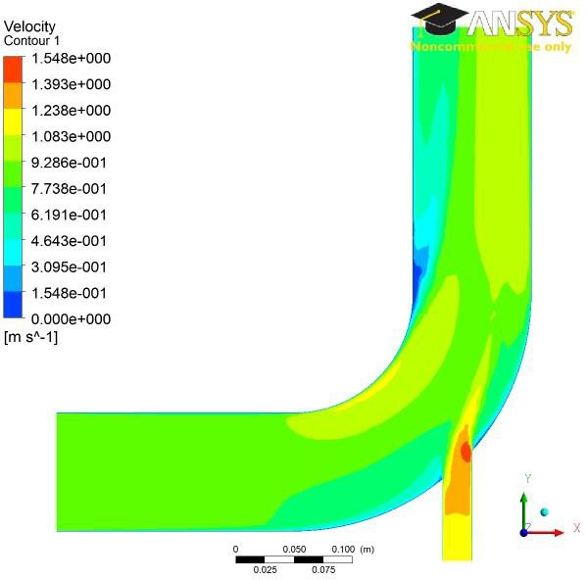

Figure 0-1 Velocity distribution on the mid‐plane for an inlet velocity for case 1. This is a proper caption which is automatically numbered and then cross referenced in the text.
The figure and caption should be centred. The figure numbering starts at 1 at the beginning of each chapter. The caption should provide a brief description of what is being shown. The figure should appear in the document after it is referred to in the text. No figure should be included which is not referred to in the text. Ensure that the size and resolution of images imported from software are sufficient to read any text.
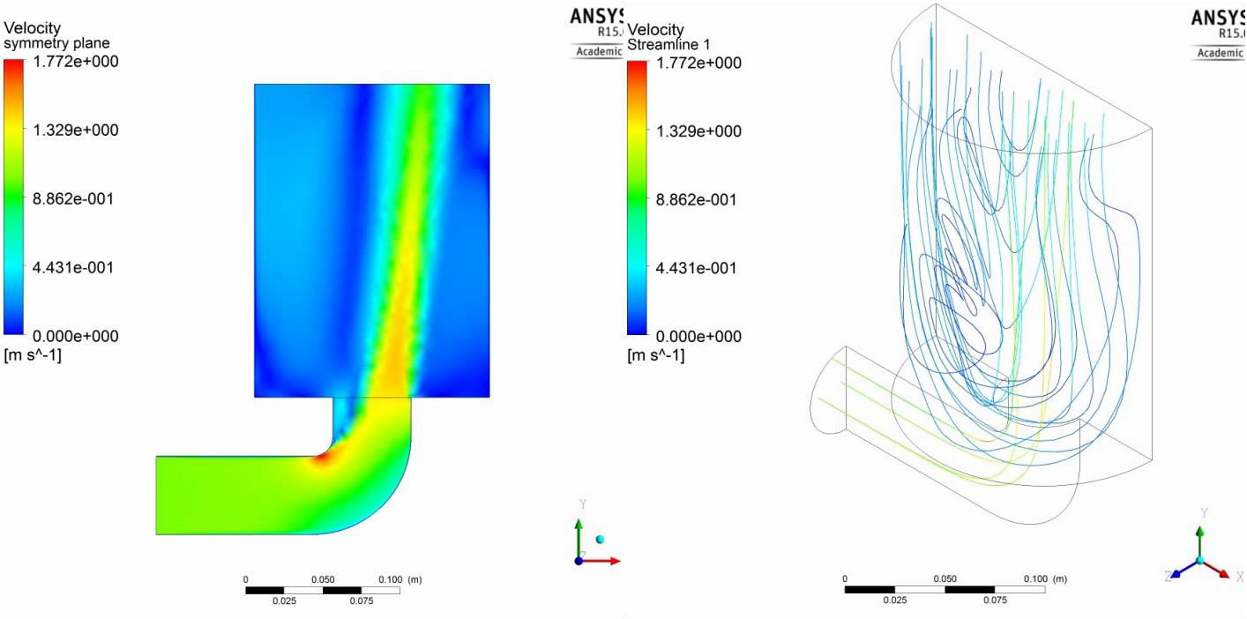
There are occasions when it is useful to group several related images together in a single figure. In this case, each sub‐plot should be labelled (a), (b), (c) etc. and may even have a caption associated with each. An example of this situation can be seen in Figure 0-2. Even if there are captions for each sub‐plot, a caption for the figure as a whole is still required. Word is now as powerful as LaTeX in handling figures and multiple captions. Thus the labelling below is done using a table with no columns to handle the layout. This is a neat trick in Word to avoid the use of columns and section breaks.
- Velocity distribution on the mid‐plane (this text is in a table with no borders) | - Streamlines, coloured by velocity magnitude (this text is in a table with no borders)
Figure 0-2 Velocity field for VINLET=1.0 m/s. The text has the style “caption”

Tables
Tables are numbered in the same way as figures. Typically tables also have a short caption, but this is not universally true, as shown in Table 0-1. The number and caption appear above the table here, not below as with figures. That’s mainly dictated by style in your discipline, so go with what you have seen in papers you have read in your area. Again, no table should appear in the report which has not been referred to in the text. Tables should come after they are discussed in the text. The exact formatting of the table depends somewhat on the content of the table, but in general, the text in the table should be the same font and size as the main text. Examples of appropriate formats are shown in Table 0-1and Table 0-2.
Table 0-1
Flow velocity (m/s) | 0.25 | 1.0
Pressure drop (Pa) | 23.5 | 521.7
Loss coefficient, K_{L} | 1.74 2.03
Table 0-2 Alternative, simple table format for pressure drop based on inlet gauge pressure
Flow velocity (m/s) | 0.25 | 1.0
Pressure drop (Pa) | 23.5 | 521.7
Loss coefficient, K_{L} | 1.74 | 2.03

Equations
All equations should be numbered sequentially. Do not restart the numbering at the beginning of each chapter. Unlike figures and tables, you may not need to refer to every equation in the text. You should take care to format equations properly. Do not simply try to use plain text. Use the equation editor. An example of how equations should appear is shown in Equation 1.
$\vec{v}=v_{1}{\vec{e}}_{1}+v_{2}{\vec{e}}_{2}+v_{3}{\vec{e}}_{3}$ (1)
If your report is very mathematical, you should use LaTeX instead of MS Word as it is much more powerful for equation editing and your report will look better.

Referencing published work
It is important to give appropriate credit to other people for the work that they have shared through publications. In fact, you must sign a declaration in your report stating that you understand the nature of plagiarism. As well as avoiding plagiarism, citing results or data from the literature can strengthen your argument, provide a favourable comparison for your results, or even demonstrate how superior your work is.
There are many styles to reference published work. For example, the parenthetical style (which is also called the Harvard style) uses the author and date of publication (e.g. “Smith and Jones, 2001”). There is also the Vancouver (or the citation sequence) style, which is shown in this document. In the Vancouver style, the publications are cited using a bracket number which refers to the list in the Bibliography section at the end of the report. The references are listed in order that they are cited in the report. A variant is name sequence style in which the publications are referenced by number, but the list is arranged alphabetically. For example, using the IEEE style, the text might say:
several studies have examined the sound field around tandem cylinders generated by flow [1, 2], while other investigations have focused on the effect of an applied sound field on the flow [3]. Papers from conference proceedings [4], books [5] and technical reports [6, 7] can be dealt with in the same style.
The IEEE style has the advantage that it is a little more compact in the text and does not distract from the flow of the sentence if there are a lot of citations. However, it has the disadvantage that it is not immediately clear to the reader what particular work has been referenced. You can use author names directly and discuss the work of Finnegan et al. [2] similar to this sentence to make it more readable.
It does not matter which particular referencing style is used as long as three important considerations are observed:
- the referencing style used throughout the document is consistent;
- all material used or discussed in the text are properly cited;
- nothing is included in the reference list that has not been cited.
Check with your supervisor as they may have a strong opinion on what you should use.
It is strongly recommended that you use a bibliographic tool, such as, as this will facilitate compliance with these three requirements. Endnote allows you to use specific referencing formats very easily and you can automatically build a bibliography directly from Google Scholar or Web of Science. Be aware that Web of Science is more reliable for giving the full record. Do NOT use footnotes for referencing in MS Word – learn how to use Endnote.

Reference
Note this reference is just for illustration purposes and was NOT generated with Endnote and hence is not well formatted. Learn to use Endnote.
- Fitzpatrick JA. Flow/acoustic interactions of two cylinders in cross‐flow. Journal of Fluids and Structures. 2003;17:97‐113.
- Finnegan SL, Meskell C, Ziada S. Experimental Investigation Of The Acoustic Power Around Two Tandem Cylinders. Journal of Pressure Vessel Technology. 2010;132:041306 (12 pp.).
- Hall JW, Ziada S, Weaver DS. Vortex‐shedding from single and tandem cylinders in the presence of applied sound. Journal of Fluids and Structures. 2003;18(6):741‐58.
- Jordan P, Fitzpatrick JA, Meskell C, editors. Array Beampattern Control for Measurement of Propeller Noise. 7th AIAA/CEAS Aeroacoustics Conference; 2001: AIAA.
- Paidoussis MP, Price SJ, Langre Ed. Fluid‐Structure Interactions (cross‐flow‐ induced instabilities) New York: Cambridge University Press; 2011.
- Reyes LA. Power Uprate Program Status Report – SECY‐07‐0090. U.S. Nuclear Regulatory Commission, 2007 May 2007. Report No.: ML070930101.
- IEA. Technology Roadmap ‐ Geothermal Heat and Power. Paris: IEA; 2011.

Appendix A1
You may use appendices to include relevant background information, such as calibration certificates, derivations of key equations or presentation of a particular data reduction method. You should not use the appendices to dump large amounts of additional results or data which are not properly discussed. If these results are really relevant, then they should appear in the main body of the report.

Appendix numbering
Appendices are ideally numbered sequentially, A1, A2, A3 but this is not as easy to set up in MS Word and is likely to compromise the rest of your heading numbering system unless you really understand styles and sections in detail. Hence, we have just incorporated that into the heading name here as a compromise. The sections, figures and tables within appendices are numbered in the same way as in the main text. For example, the first figure in Appendix A1 would ideally be Figure A.1. but it will be 4.1 here. Equations continue the numbering from the main text.

More Appendix data
Is here

You should minimise your use of footnotes in general

